

School of Computer Science

Course Code – INT-108

Course Title: Python Programming

Project Topic: ROCK, PAPER, SCISSORS GAME

Submitted By: TSV Sudhiksha

Section: K22PU

Roll no.: RK22PUA24

CODE

import random

choice = ("rock", "paper", "scissors")

playing = True

while playing:

player = None

computer = random.choice(choice)

while player not in choice:

player = input("Enter a choice (rock, paper, scissors): ")

print("Player: {player}")

print("Computer: {computer}")

if player == computer:

print("Oops!!! It's a tie....")

elif player == "rock" and computer == "scissors":

print("You win!!!")

elif player == "paper" and computer == "rock":

print("You win!!!")

elif player == "scissors" and computer == "paper":

print("You win!!!")

else:

print("You lose:(")

if not input("Play again? (y/n): ").lower() == "y":

playing = False

print("Thanks for playing :)")

WORKING OF THE CODE

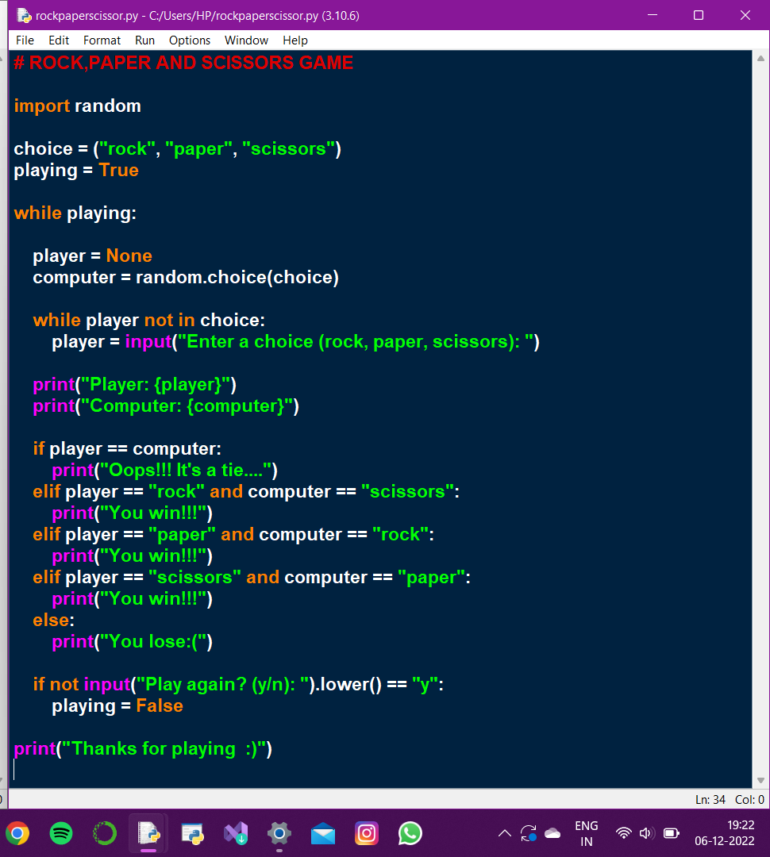

OUTPUT OF THE CODE

